ASSIGNMENT 4.1
HNO:2303A51706
BATCH:28
Question 1: Customer Email Classification
Zero-Shot Prompt
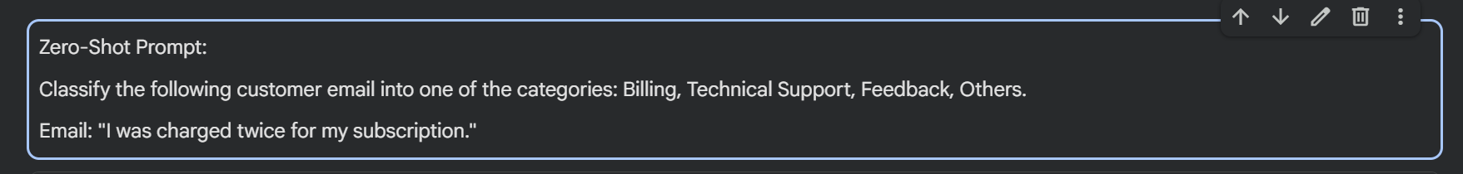
Code:
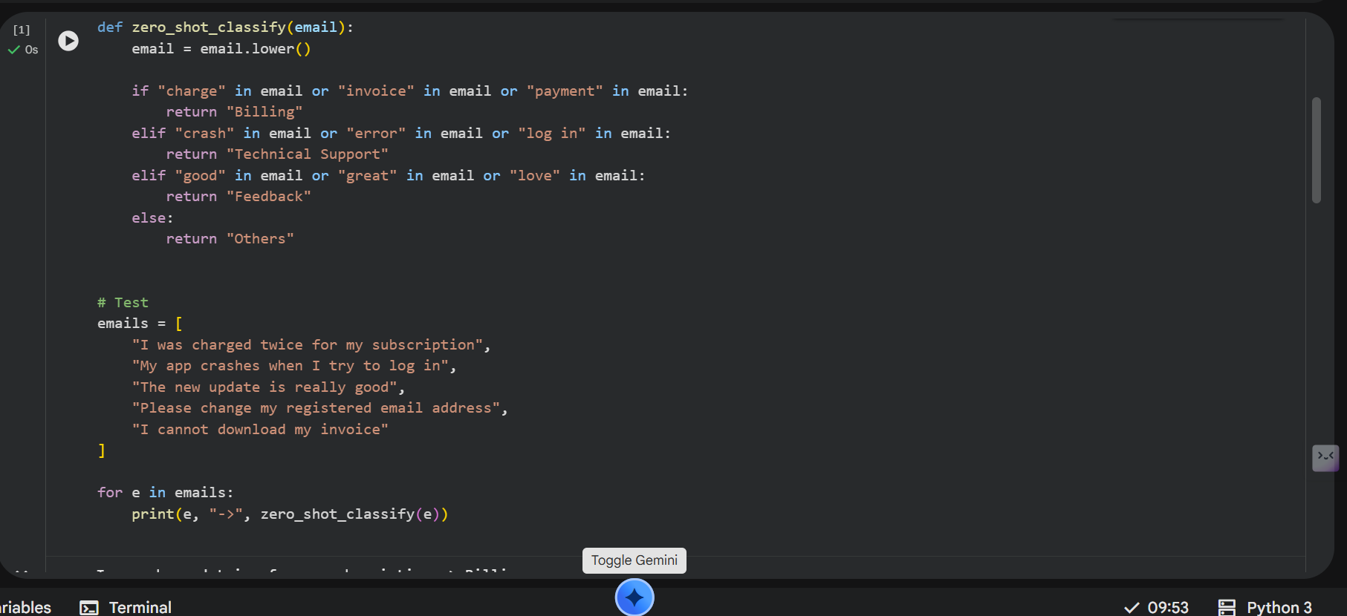
Output:
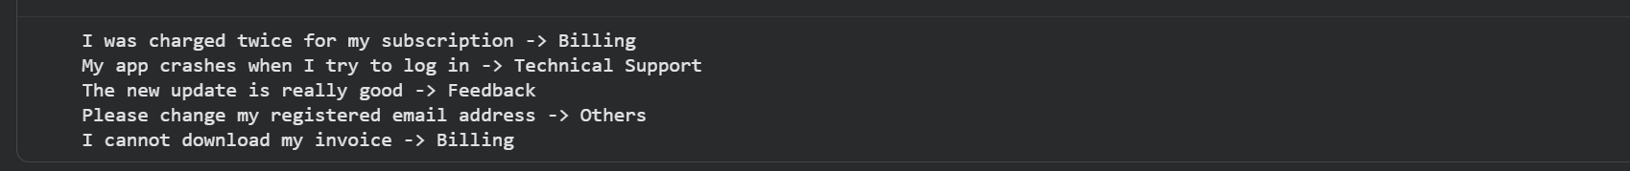
Justification:
Zero-shot prompting performs classification without providing any prior examples. The model relies only on the instruction and basic keyword understanding. While it works correctly for simple and clear emails, it may fail in ambiguous cases due to the lack of guidance. This demonstrates the limitation of zero-shot prompting when minimal context is provided.
One-Shot Prompt:
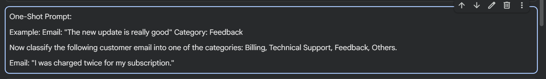
Code:
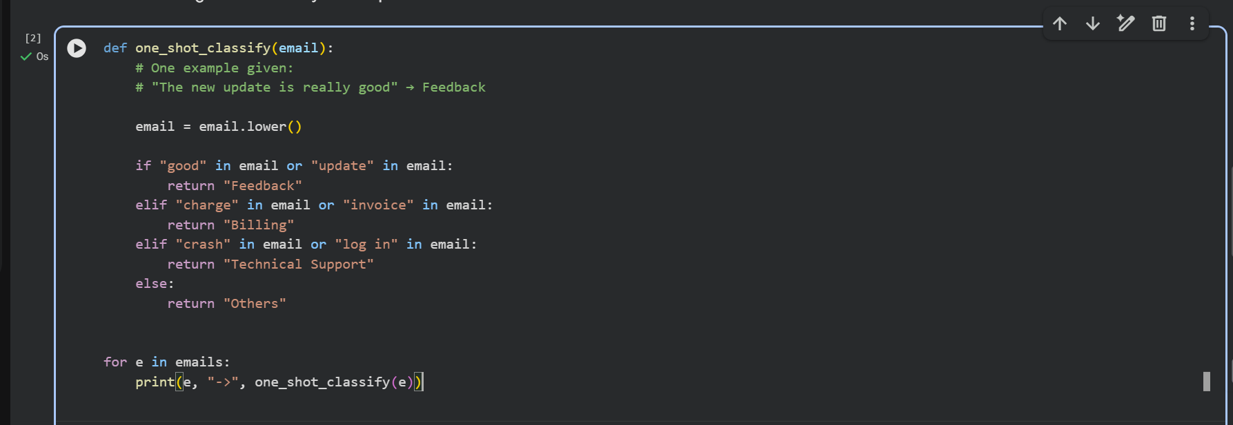
Output:
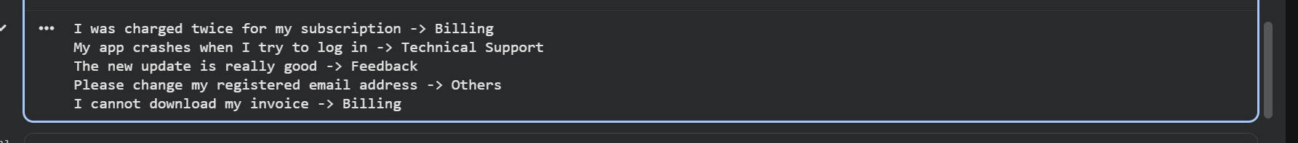
Justification:
One-shot prompting improves classification accuracy by providing a single labeled example. This example helps the model understand how an email should be mapped to a category. Compared to zero-shot prompting, one-shot prompting produces more consistent results and reduces ambiguity by giving a reference pattern.
Few-Short Prompt:
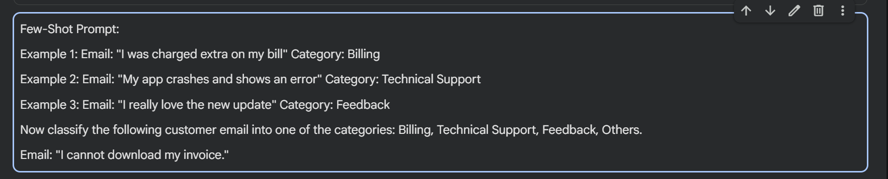
Code:
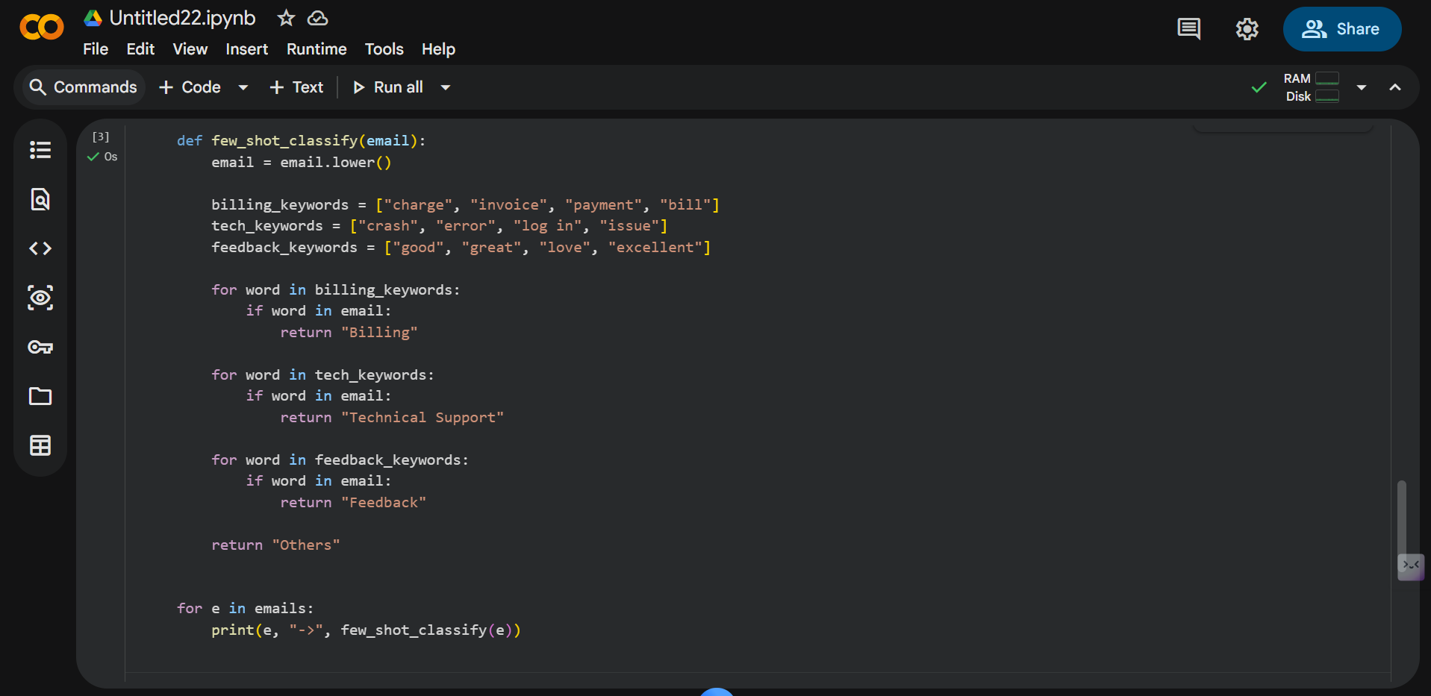
Output:
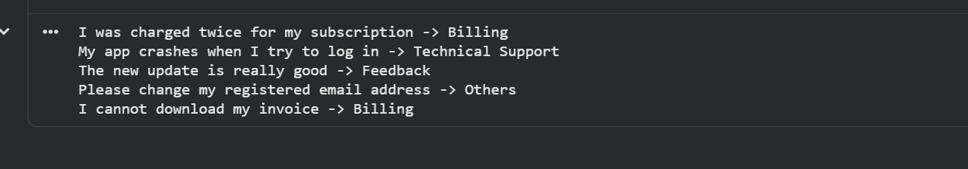
Justification:
Few-shot prompting provides multiple labeled examples, allowing the model to learn patterns more effectively. By observing several examples across different categories, the model achieves higher accuracy and better consistency. Few-shot prompting handles varied email types more reliably than zero-shot and one-shot approaches.
Among the three prompting techniques, zero-shot prompting offers simplicity but limited reliability. One-shot prompting improves performance by introducing a reference example. Few-shot prompting delivers the best results by providing multiple examples, enabling more accurate and robust classification. This demonstrates that increasing contextual examples improves AI response quality.

